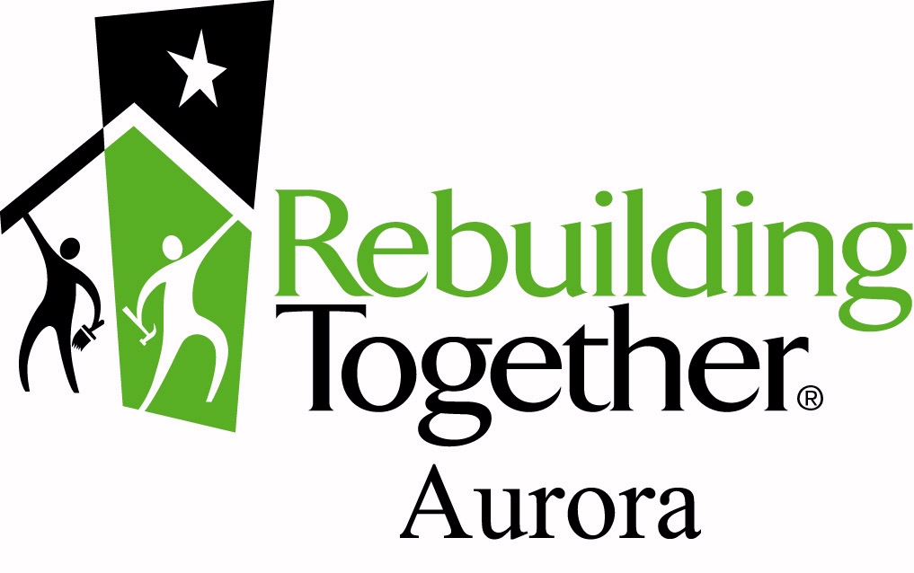
Rebuilding Together Aurora
31 W Downer Pl, Suite 402

Aurora, IL 60506
Office Line: (630) 801-9044
Fax Line: (630) 801-9048

Dear Homeowner:

Rebuilding Together Aurora (RTA) is a safe and healthy housing organization which utilizes skilled and general volunteers to provide home repairs for qualified, low-income homeowners. RTA provides these services at no cost to qualified homeowners.

RTA Qualifications for services:

- The property must be owner occupied and be the primary residence
- The property may not be fully rented. However, if the homeowner is collecting rental income for a portion of the home, this may be acceptable. Rental income must be considered as income and evidence provided as part of the documentation requirements.
Household size | Annual income  (rev. 2018)
1 person | $47,400
2 people | $54,200
3 people | $60,950
4 people | $67,700
5 people | $73,150
6 people | $78,550
7 people | $83,950
- The income must fall within or below 80% of the HUD Low-Income standards.
- The homeowner must be an elderly person; a person with disabilities or who cares for; a veteran; or a parent/guardian with child(ren) 18 or under living in the home.

- The homeowner is not able to do necessary repairs/modifications due to cost or physical constraints

In order for RTA to determine eligibility an applicant must complete the Homeowner Application and provide the following documentation that indicates:

- Proof of ownership via Title, Deed, Warranty Deed, or Quit Claim Deed
- Current income verification , including total household income of all persons living in the home
- Most recent 30 days of pay stubs (if applicable) for all persons
- Most recent filed tax return for all persons
- A copy of your bank statement displaying public assistance, if applicable
- Evidence that the Homeowners insurance policy is in force
- Evidence that all mortgage payments are current
- Photo ID

After the application is received you will be notified about the status of your application.

THERE IS NO GUARANTEE OF SERVICE BY APPLYING TO REBUILDING TOGETHER AURORA

To help with the safety of your home, if you’re applying for a roof or weatherization needs, we highly recommend also applying to:

Neighborhood Project  630-906-9400  32 South Broadway Aurora, IL 60505  Provides funding for roofs, porches, furnaces, electrical and plumbing upgrades. | Community Contacts  847-697-8800  100 S. Hawthorne St. Elgin, IL 60123  Provides weatherization needs for eligible homes

Rebuilding Together Aurora has 3 programs through which homeowners may be served:

- SAFETY AND ACCESSABILITY SERVICE “SAFE AT HOME”

Through the Safe at Home program, Rebuilding Together Aurora provides no-cost, home safety and accessibility modifications for low-income homeowners who are seniors, living with a disability or caring for a loved one with a disability.

GOALS
Fall Prevention/Accessibility | General Safety | Health/Fire Safety & Prevention

Safe at Home Program approved repairs:

Mobility Repairs Aging in place Safety Repairs
Flooring replacement  Hand railings  Accessibility ramps  Broken or weak steps  Grab bars  ADA accessible doorways  Walk-in shower  ADA height toilet  Shower chairs | Lever door knobs  Lever faucets  Additional lighting | Electrical failures --unsafe or fire hazards  Chimney tuck-pointing/flashing  Mold from water damage  Smoke detectors/CO2 detectors  Dead bolts & locks  Peep holes  Exterior doors  Broken windows

- GENERAL REPAIR SERVICE

Volunteer based service engaging corporate, faith based, and civic groups in providing a range of repairs, based on their skill level, during a special day of service during the year. Homeowners that do not qualify or who are seeking non Safe at Home services will be placed on a waiting list for this service program. Because these services are provided through volunteers there is no guarantee of service. RTA can only serve as many homeowners as resources allow. Homeowners that fall within the boundaries of annual rebuilding events that RTA hosts will be notified and services provided through those events.

GOALS

Improve the overall health and well-being of a home by making the home warm, safe, and dry

ANNUAL APRIL REBUILDING EVENT “COMMUNITY BLOCK BUILD”

Through an annual Community Block Build, taking place during the last weekend of April, Rebuilding Together Aurora provides no-cost, larger scale home repairs for targeted homes in a neighborhood that has been selected by RTA. This program takes a block-by-block, house-by-house approach to improving the health and well-being of low-income households.

There is no warranty on work completed by Rebuilding Together Aurora.

Rebuilding Together Aurora
31 W Downer Pl, Suite 402

Aurora, IL 60506
Office Line: (630) 801-9044
Fax Line: (630) 801-9048

To submit this application, please use one of the following options:

- Mail to above address
- Scan and email to shay.olson@rtaurora.org
- Call our office to make an appointment to drop off

Office Use Only:
Received on: _____________________ Application # ___________________________ FOIA Req/Complete: ______________/______________

NRSA: Y/N Ward: _________________ Historic District: Y/N _______________________________________

- I have read and understand the introduction letter of application. (Required)

- Homeowner Information
Name of Applicant: |  |  |  | Age: |  | Sex:  F M | Disabled:  (Yes) / (No)
Street Address: |  |  |  | Zip Code:
Phone # |  | Alternate Phone #
Primary Contact (if not homeowner) |  | Relationship: |  |  | Phone #
Marital Status:  - Married  - Living with a partner  - Divorced/separated  - Widowed  - Single/never married | Race:  - African American/Black  - Asian  - American Indian/Alaskan native  - Pacific Islander  - White/Caucasian |  |  |  | Ethnicity:  - Hispanic/Latino  - Not Hispanic /Latino  - Other(Please Specify)  ______________________________  ______________________________
How many years have you lived in your home? |  |  | Do you own your property? (Yes) / (No)
Do you have a mortgage on the home? (Yes) / (No) |  |  | Are payments up to date? (Yes) / (No)
Are there renters in the home? (Yes) / (No) |  |  | Is this your only residence? (Yes) / (No)
Have you been cited by the city for housing code violations? (Yes) / (No)
(Please provide a copy of the citation with application)
Code violations:
Have you applied before to Rebuilding Together Aurora or Christmas in April? (Yes) / (No)
When:
How did you hear of Rebuilding Together Aurora? (Please circle)

Flyer Newspaper Alderman Senior Center Friend/Neighbor Other:

II. Residents (Complete the following for ALL members of household)
Name: | Age: | Relationship: | Ethnicity/Race: | Disabled: (Yes) / (No)
Name: | Age: | Relationship: | Ethnicity/Race:: | Disabled: (Yes) / (No)
Name: | Age: | Relationship: | Ethnicity/Race: | Disabled: (Yes) / (No)
Name: | Age: | Relationship: | Ethnicity/Race: | Disabled: (Yes) / (No)
Name: | Age: | Relationship: | Ethnicity/Race: | Disabled: (Yes) / (No)

III. Disabilities/Chronic Illness (Please check what disabilities apply to the residents of the home)
- Mobility  - Hearing Impairment  - Sight Impairment | - Health Impairment  - Mental Disability  - Other
If other was selected please describe:
Does anyone in the home suffer from a chronic illness? (Yes) / (No)
Please describe:
Do you have caregiver that comes to the home? (Yes) / (No)

IV. Military Background
Are you a Veteran or is/was your spouse a Veteran? (Yes) / (No) | Branch of Service: | Dates of Service:
Is anyone else listed as living in the home a Veteran? (Yes) / (No)
Who: | Branch of Service: | Dates of Service:
Is anyone in the home currently serving in the Armed Forces? (Yes) / (No)
Who: | Branch of Service: | Dates of Service:

V. Verification of current income (Please add ALL income sources for all member in the household 18 years of age and older : (All income sources: employer, self-employment, unemployment, pensions, VA benefits, disability, Social Security, child support, foster care, adoption assistance, rental income, etc.) Please attach proof of these documents with application when submitted)
Annual Salaries and Wages | $
Rental Income | $
Pensions, Retirement, Death Benefits | $
Social Security Benefits | $
Unemployment, Disability, and Worker’s Comp | $
Other (Child Support, TANF, Military Comp, etc) | $
Total | $
VI. Homeowner Requested Repairs
RTA prioritizes our efforts towards safe and healthy home repairs. The final decision on what work can be done on your home with consideration of volunteer and financial resources will be made at the discretion of RTA. Attach a separate piece of paper if there is not enough space to list all repairs. We cannot promise or guarantee assistance or the extent of repairs done.

- I have read the above statement and understand that there is no guarantee of service
What is the nature of the problem(s) for which you are requesting assistance?
General:  - Insulation  - Plumbing Repairs  - Appliances  - Carpentry Repairs | - Electrical repairs  - Doors/Windows  - Roofing Repairs  - Painting
Accessibility Modifications:  - Ramp  - Low Rise Steps | - Grab Bars  - Walk In Shower

VII. Homeowner Priority Repairs ( Please list your top-priority repairs for the home)
1.

2.

3.

4.

5.

VIII. Homeowner Agreement (Please read and initial next to each statement)
I understand that Rebuilding Together Aurora (RTA) is funded by charitable donations and grants to provide assistance to low-income seniors, veterans, disabled homeowners, or families with children who have no other means to afford home repairs.
I understand that RTA does not guarantee service, regardless of application status or homeowner eligibility.
I have no intention of selling this home or transferring ownership of this home within three years of the signature date of this document.
I authorize Rebuilding Together Aurora and its representatives to complete any required paperwork for obtaining building permits that may be necessary to repair my home.
I understand that Rebuilding Together Aurora is a neighbor-helping-neighbor organization, and I will do everything possible to get family and friends to help me.
I understand that, in the presence of Rebuilding Together Aurora volunteers, the use of alcohol, sale or use of drugs other than as prescribed by a doctor, or any behavior which threatens or creates discomfort to the volunteers on my/our part or the part of my/guests or family is cause for immediate cancellation of all scheduled work at my home.
I further authorize Rebuilding Together Aurora and its representatives to conduct such investigation as it deems necessary to confirm the safety of its volunteers, including the use of criminal background checks, the procurement of consumer reports, and the consultation with the local police department as to police reports at the residence. The information being obtained will not be used in violation of any federal or state equal opportunity law or regulation.
I certify that the above information is true and correct to the best of my/our knowledge. I also authorize you to check any references necessary to complete the processing of this application for the purpose of receiving housing rehabilitation through Rebuilding Together. I also understand that this information will be kept confidential and will be used strictly for the purpose of determining my/our eligibility for the Rebuilding Together programs.

I have included the following documents with this application (REQUIRED):
- Proof of ownership via Title, Deed, Warranty Deed or Quit Claim Deed
- Current income verification , including total household income of all persons living in the home
- Evidence that the Homeowners insurance policy is in force
- Evidence that all mortgage payments are current

Signature of Applicant |  | Date
Printed Name
Preparer Signature (if not homeowner) |  | Date
Printed Name | Phone | Relationship

Rebuilding Together Aurora does not discriminate against, nor exclude from participation, any applicant for assistance on the ground of their race, color, religion (creed), sex, age, disability, sexual orientation, ancestry, national origin, citizenship status, or any other basis prohibited by applicable law.

